**Graphs for the exercise**

Histogram for Latitude distribution

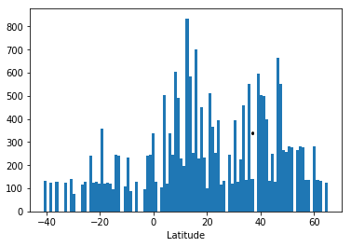

Top Ten Food Producers

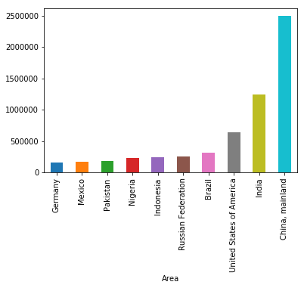

Python Graph Gallery

<https://python-graph-gallery.com/>

Matplotlib

<https://matplotlib.org/gallery/index.html>

Seaborn

<https://seaborn.pydata.org/examples/index.html>

<https://drive.google.com/drive/folders/1dzGjsJ1mprtiS6HQZT6lMe1Sor-CeV2W?usp=sharing>